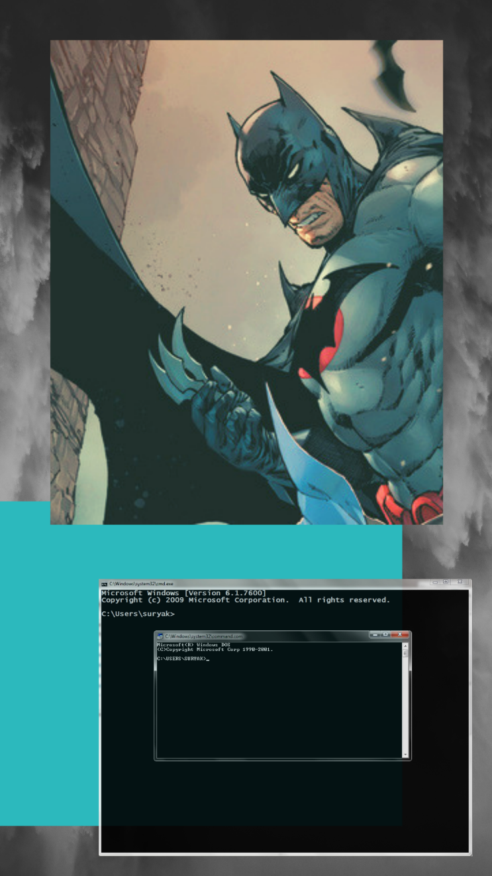

BATCHMAN

A batch file report and user manual

Sofia Mazloum | Operating Systems | ITfuc-18 | May 16, 2019

# BATCHMAN: THE ESSENCE

*BatchMan* is a project written using the CLI or the Command Line Interface of Windows OS. It is essentially supposed to be a small project with a few functionalities for usability and to heed boredom (in an easy way). The interface is very clean and easy to read and understand.

## Its features

* Directory menu
* Simple Calculator
* Old school games
* Web browser
* IP address information
* Theme music player

## introduction

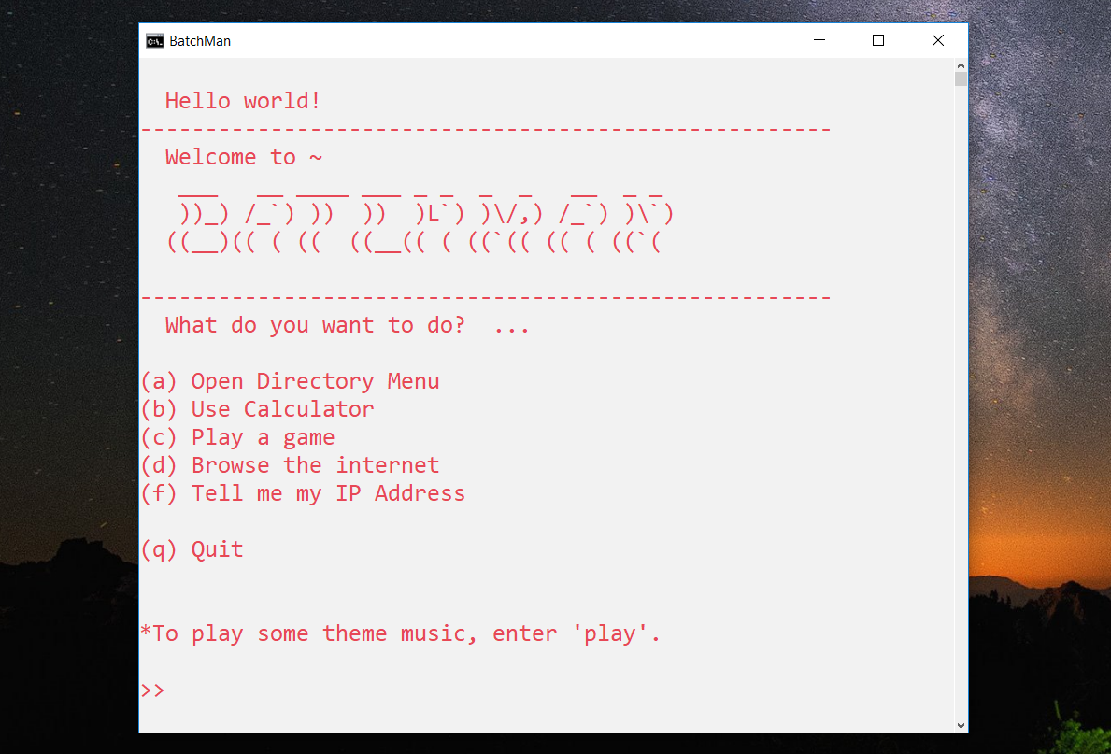The batch file opens up with a nice flesh white tone background and with red text. Within it you can read a list of five options to navigate through, a quit option, and also the ability to play theme music (of the project).

## Directory menu

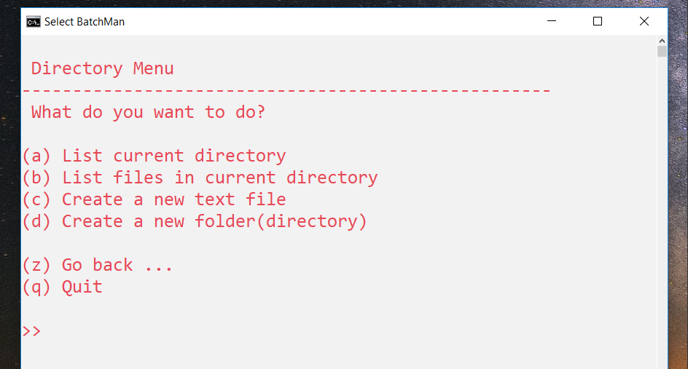To open the directory menu, enter [a] or [A] with your keyboard.

Within the directory menu you have the ability to do the following:

* List current directory
* List files in current directory
* Create a new text file
* Create a new folder

You also have the ability to go back to the main page, using [z], or quit, using [q].

### List current directory

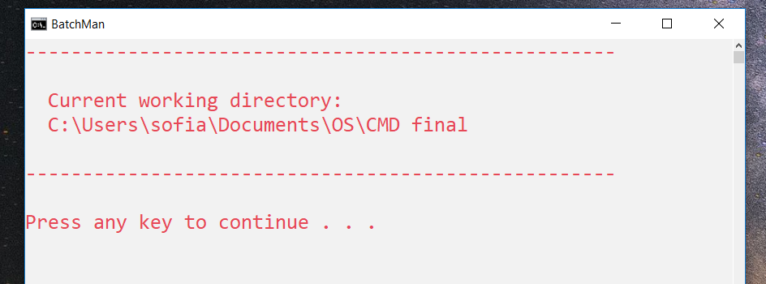This option allows you to list the current directory that you are working on, or the folder in which the file *BatchMan* was opened. To select this option, enter [a] or [A] with your keyboard.

### List files in current directory

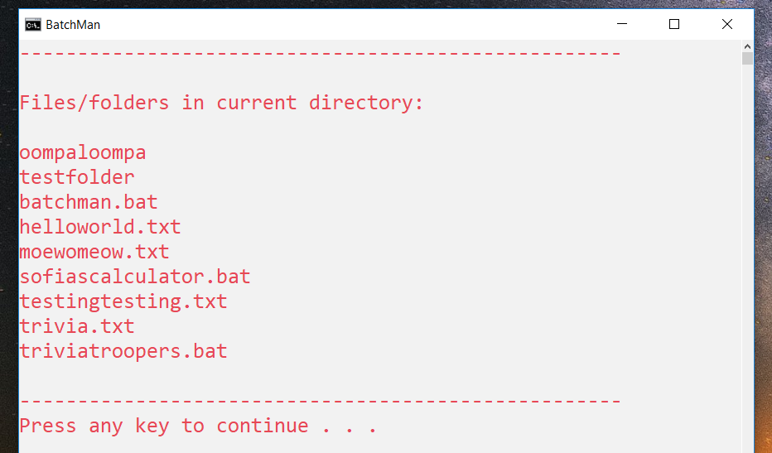This option allows you to list all the files and folders that exist in the current working directory, or folder in which *BatchMan* is running. To select this option, enter [b] or [B] with your keyboard.

### Create new text file

This option allows you to create a new text file in the current working directory.

To create a new text file, you will be prompted to enter a name for the text file. After entering a name using your keyboard, the notepad editor will open and prompt you to create the file. Press [Yes], type whatever you want into your new text file, and finally save and close it to exit.

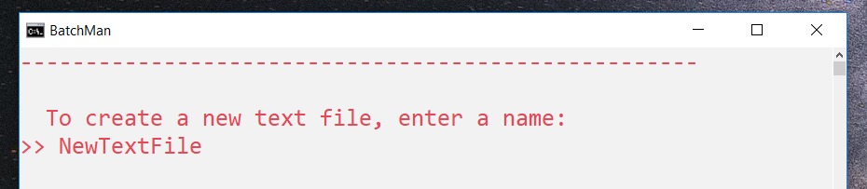To select this option, enter [c] or [C] with your keyboard.

### 

### Create new folder

This option allows you to create a new folder (or directory) in the current working directory.

To create a new folder, you will be prompted to enter a name for the new folder. After entering a name using your keyboard, a new folder will have been created using the name inputted. You can check this by listing the files and folders in the current directory to verify its creation.

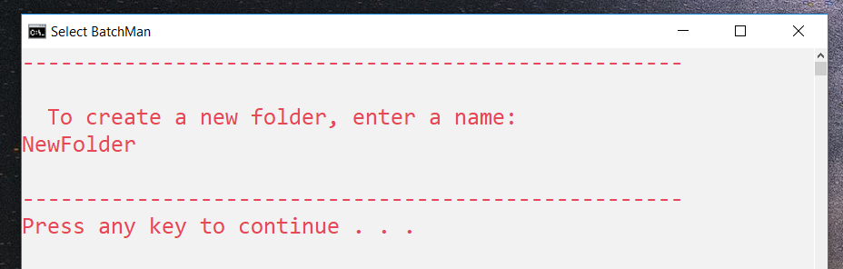To select this option, enter [d] or [D] with your keyboard.

## Calculator

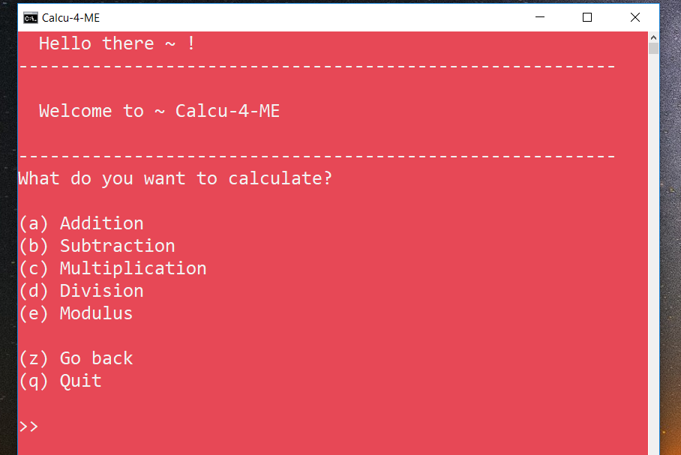To use the calculator, enter [b] or [B] with your keyboard. After opening the calculator, you will be greeted with the main page of *Calcu-4-ME*. The background is a bright red with white text.

Within the calculator, you have the ability to do the following functions:

* Addition
* Subtraction
* Multiplication
* Division
* Modulus

You also have the ability to go back to the main page of the calculator, using [z], or quit, using [q].

### Addition

This option allows you to use the addition function with two integers. To select this option, enter [a] or [A] with your keyboard.

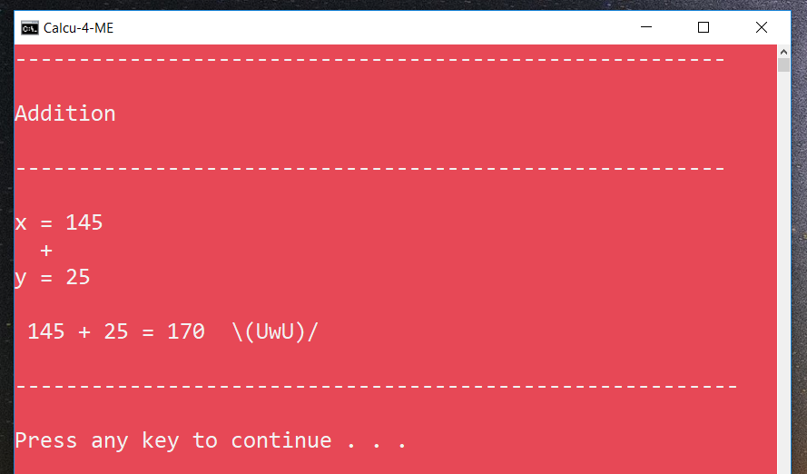Firstly, enter your first integer x, then, enter your second integer y. You will finally be presented with the sum of your integers in a nice and quaint equation.

### Subtraction

This option allows you to use the subtraction function with two integers. To select this option, enter [b] or [B] with your keyboard.

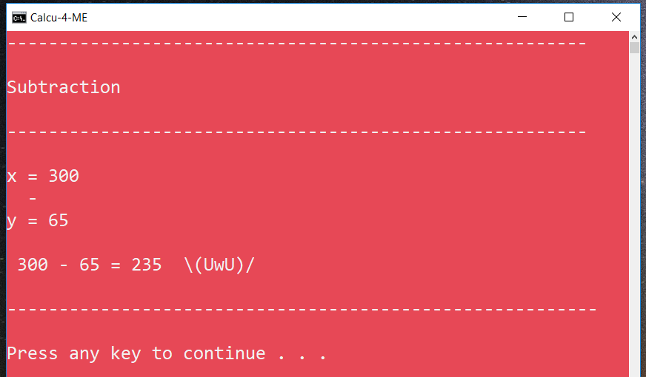Firstly, enter your first integer x, or your minuend, then, enter your second integer y, or your subtrahend. You will finally be presented with the difference of your integers in a nice and quaint equation.

### Multiplication

This option allows you to use the multiplication function with two integers. To select this option, enter [c] or [C] with your keyboard.

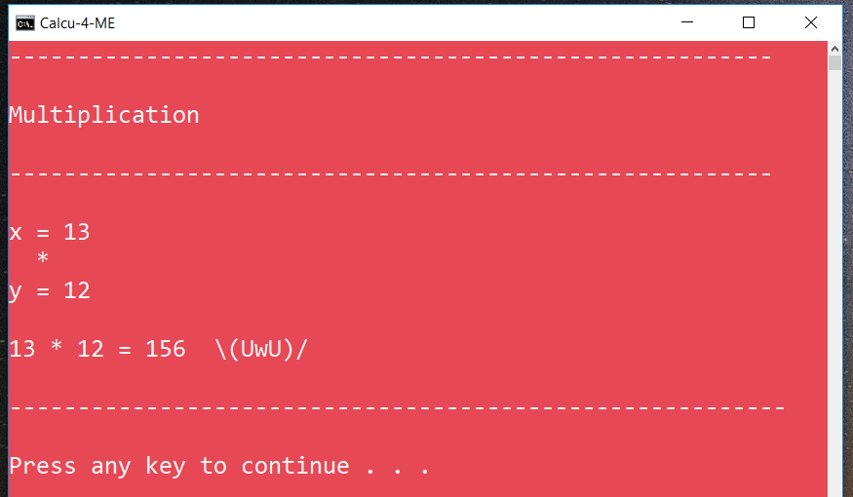Firstly, enter your first integer or factor x, then, enter your second integer or factor y. You will finally be presented with the product of your integers in a nice and quaint equation.

### Division

This option allows you to use the division function with two integers. To select this option, enter [d] or [D] with your keyboard.

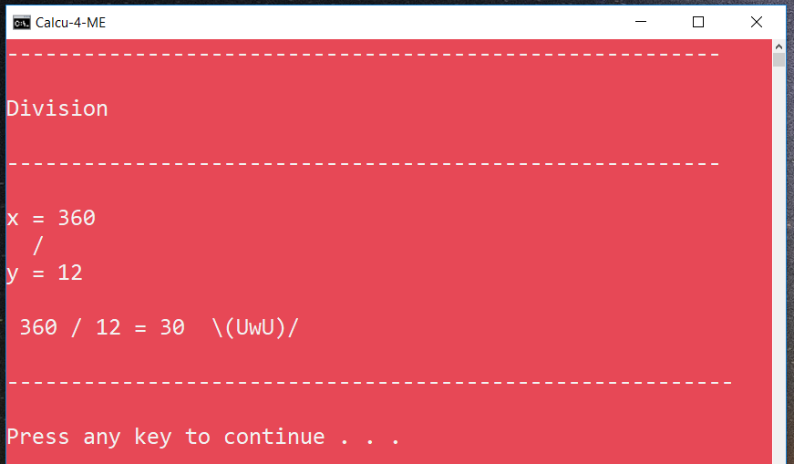Firstly, enter your first integer x, or your dividend, then, enter your second integer y, or divisor. You will finally be presented with the quotient of your integers in a nice and quaint equation.

### Modulus

This option allows you to use the modulo function with two integers. To select this option, enter [e] or [E] with your keyboard.

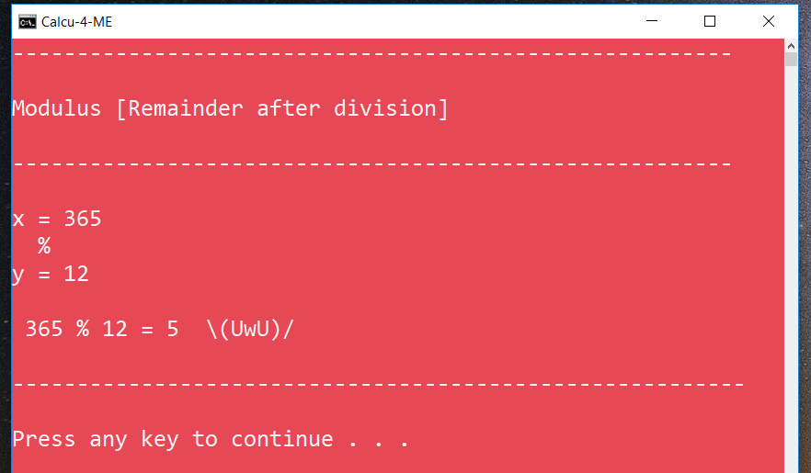Firstly, enter your first integer x, or your dividend, then enter your second integer y, or your divisor and modulus. You will finally be presented with the remainder of your integers in a nice and quaint equation.

## Old school games

To select this option, enter [c] or [C] with your keyboard. You will be presented with the game centre containing a list of three games, namely:

* Trivia Troopers
* Web Sudoku
* Chess on Lichess

You also have the ability to go back to the main page, using [z], or quit, using [q].

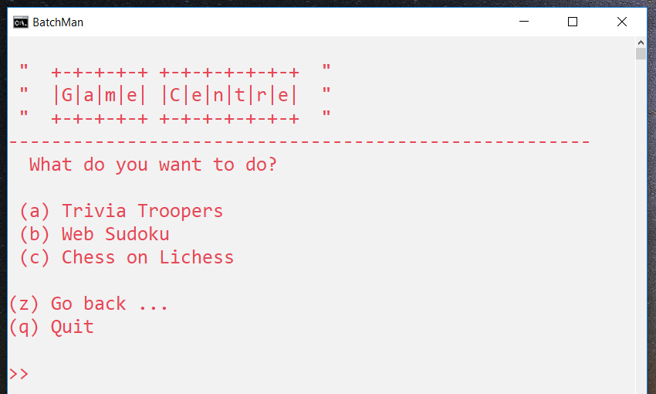

### Trivia Troopers

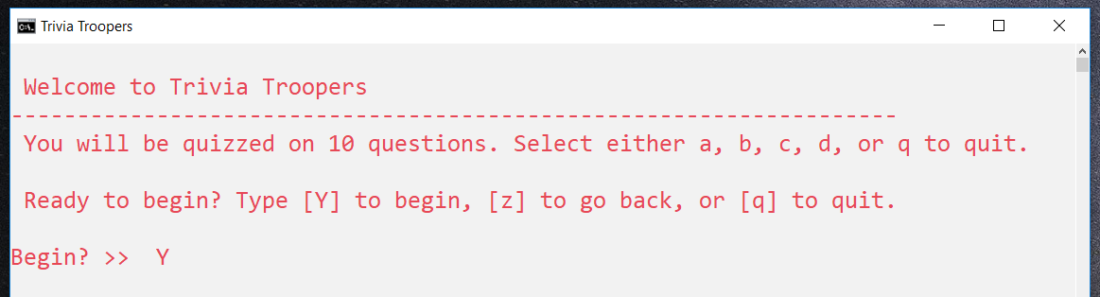Trivia troopers is a trivia game that quizzes you on ten (10) questions with multiple-choice answers. To select this option, enter [a] or [A] with your keyboard. Within the game, you will be asked questions and prompted to input the correct answer from a list of four choices (a, b, c, and d). A correct answer scores you one point, and your total score is hidden until the end of the game where the accumulation of your correct answers is found in your score out of 10.

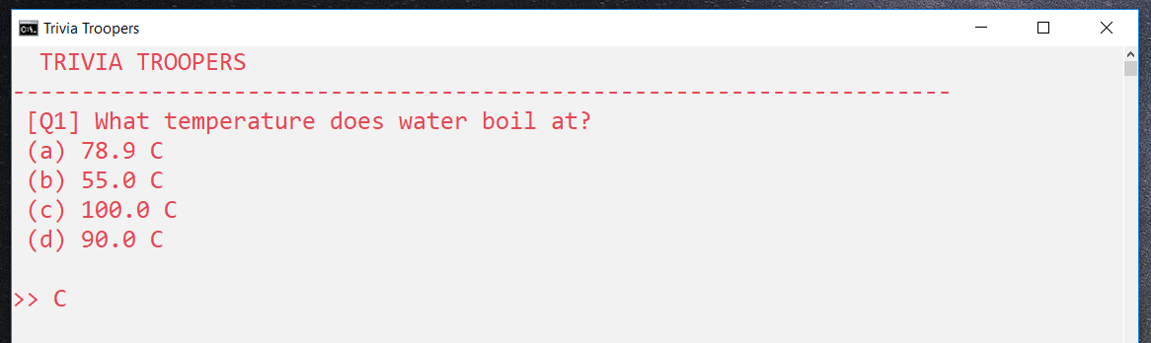Q*uestion 1*

### Web Sudoku

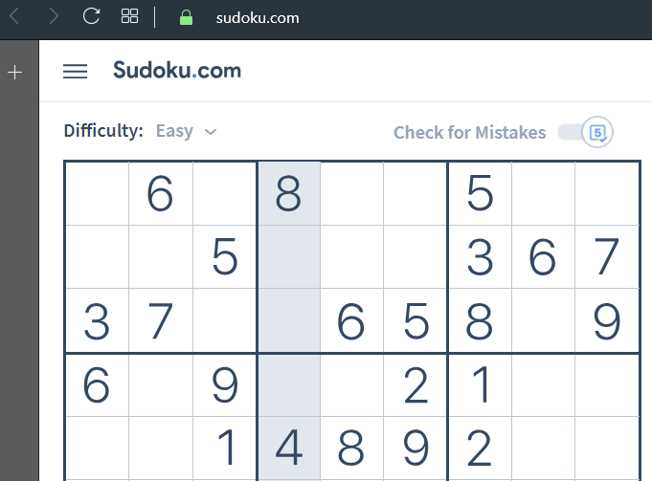This option starts Sudoku on your web browser. Sudoku is a popular logic puzzle game with the goal of filling in a 9x9 grid with numbers from 1-9 so that each row, column, and 3x3 section contain each number once and do not coincide. To select this option, enter [b] or [B] with your keyboard.

### Chess on Lichess

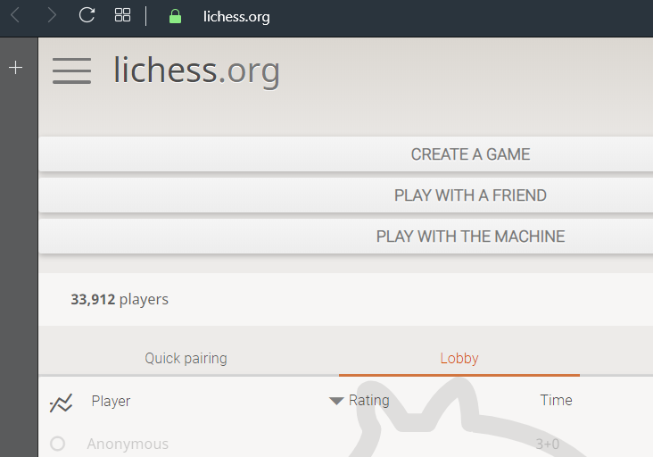This option starts Chess on Lichess on your web browser. Chess is a popular two-player strategy board game that is played on a checkered board with 64 squares arranged in an 8x8 grid. To select this option, enter [c] or [C] with your keyboard.

## Web browser

This option allows you to browse the web on your default web browser. To select this option, enter [d] or [D] with your keyboard.

There are five (5) preset websites for you to visit, as well as the option to input your own website URL. The following options are shown below:

* Mano VGTU website
* VGTU Moodle website
* VGTU Student Software website
* Gmail
* Google
* 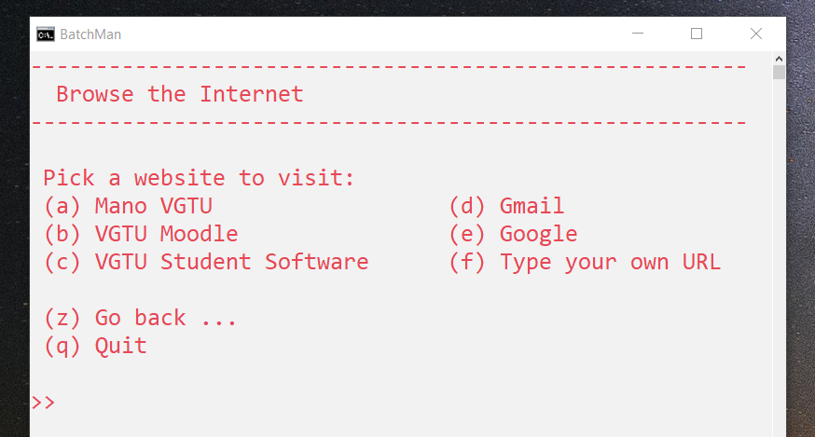Any URL or web address you want to visit

To access any of the preset websites, simply enter the letter before the option. (Ex: To open VGTU Moodle website, enter [b] or [B] with your keyboard).

To input your own URL, first enter [f] or [F] with your keyboard, and then type the complete URL of the website you want to visit.

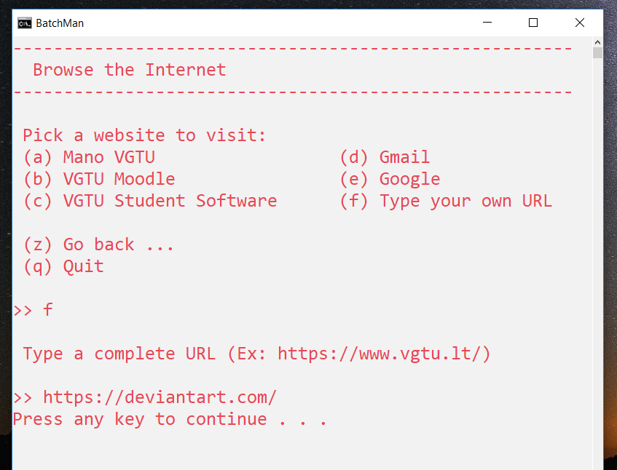

## IP address information

This option allows you to access your IP address information, such as your IPv4 Address and your IPv6 address. To select this option, enter [f] or [F] with your keyboard.

## Theme music player

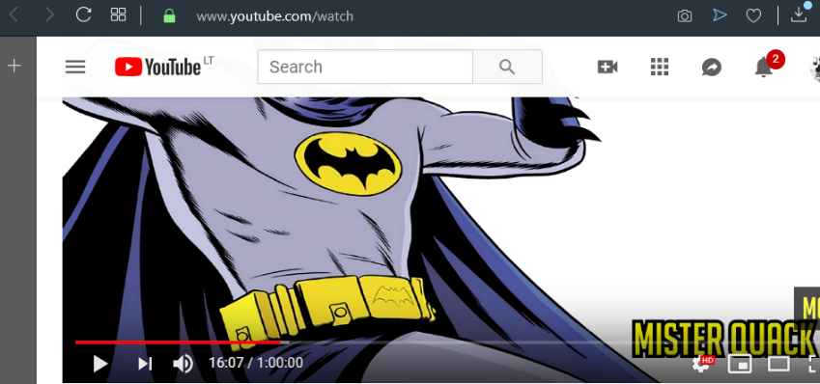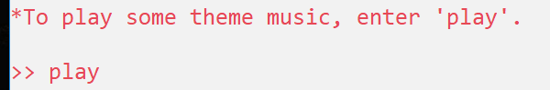The theme music player opens up a window playing a theme song for *BatchMan*. To start the theme song, enter [play] with your keyboard.

#### BatchMan Secret

The *Batchman* project has a secret that is intended only to be directed to the lecturer of the Operating Systems class of the programmer. The lecturer goes by the name Ms Inga. To reveal the secret, enter [i] or [I] with your keyboard.

The secret is not interesting or intriguing since it is a basic ASCII drawing of a pine tree with an underlying message related to Christmas, the season which is it not at the time of presentation.

*No image is placed here as it is supposed to be a secret. (Haha).*

## Quit

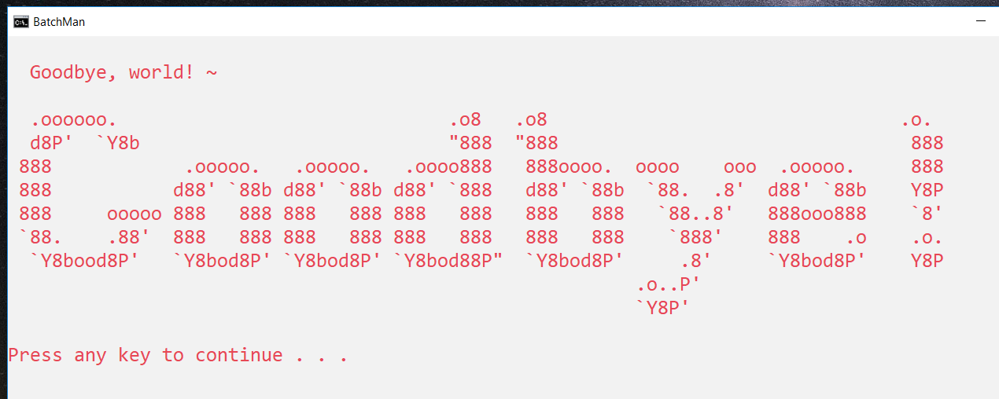The quit option is available for selection at all times during the running of *BatchMan*. To quit or exit *BatchMan*, simply enter [q] or [Q] with your keyboard. The program will greet you Goodbye.

# The Code

Project *BatchMan* has a total of three (3) files, these include **batchman.bat**, **sofiascalculator.bat**, and **triviatroopers.bat**. To make the readability of this report and access to the files and its code easier, the complete project can be found online in the repository following this address <https://github.com/mi-lk/BatchMan/>.

### batchman.bat

@echo off

color FC

title BatchMan

:Begin

cls

echo.

echo Hello world!

echo -----------------------------------------------------

echo Welcome to ~

echo ___ __ ____ ___ _ _ _ _ __ _ _

echo ))_) /_`) )) )) )`) )\/,) /_`) )\`)

echo ((__)(( ( (( ((__(( ( ((`(( (( ( ((`(

echo.

echo -----------------------------------------------------

echo What do you want to do? ...

echo.

echo (a) Open Directory Menu

echo (b) Use Calculator

echo (c) Play a game

echo (d) Browse the internet

echo (f) Tell me my IP Address

echo.

echo (q) Quit

echo.

echo.

echo *To play some theme music, enter 'play'.

echo.

set /P option=">> "

if /I %option%==a goto Dirmenu

if /I %option%==b goto Calc

if /I %option%==c goto Game

if /I %option%==d goto Web

if /I %option%==f goto myIP

if /I %option%==q goto Quit

if /I "%option%"=="play" goto Play

::Secret

if /I %option%==I goto Christmas

echo.

echo Oops! Invalid input.

echo.

pause

goto Begin

:Play

start https://www.youtube.com/watch?v=MmJ64exGII4

goto Begin

echo.

echo Oops! You didn't pick a valid option .. :c

echo.

pause

goto Begin

:Dirmenu

cls

echo.

echo Directory Menu

echo ----------------------------------------------------

echo What do you want to do?

echo.

echo (a) List current directory

echo (b) List files in current directory

echo (c) Create a new text file

echo (d) Create a new folder(directory)

echo.

echo (z) Go back ...

echo (q) Quit

echo.

set /P option=">> "

if /I %option%==a goto Cur

if /I %option%==b goto Ls

if /I %option%==c goto Txt

if /I %option%==d goto Fold

if /I %option%==z goto Begin

if /I %option%==q goto Quit

echo.

echo Oops! Invalid input.

pause

goto Dirmenu

:Cur

cls

echo ----------------------------------------------------

echo.

echo Current working directory:

echo %cd%

echo.

echo ----------------------------------------------------

echo.

pause

goto Dirmenu

:Ls

cls

echo ----------------------------------------------------

echo.

echo Files/folders in current directory:

echo.

dir /b /a /OGN

echo.

echo ----------------------------------------------------

pause

goto Dirmenu

:Txt

cls

echo ----------------------------------------------------

echo.

echo To create a new text file, enter a name:

set /P name=">> "

notepad %name%.txt

echo.

echo ----------------------------------------------------

pause

goto Dirmenu

:Fold

cls

echo ----------------------------------------------------

echo.

echo To create a new folder, enter a name:

set /P name=">> "

mkdir "%name%"

echo.

echo ----------------------------------------------------

pause

goto Dirmenu

:Calc

start sofiascalculator

goto End

:Game

cls

echo.

echo " +-+-+-+-+ +-+-+-+-+-+-+ "

echo " |G|a|m|e| |C|e|n|t|r|e| "

echo " +-+-+-+-+ +-+-+-+-+-+-+ "

echo ------------------------------------------------------

echo What do you want to do?

echo.

echo (a) Trivia Troopers

echo (b) Web Sudoku

echo (c) Chess on Lichess

echo.

echo (z) Go back ...

echo (q) Quit

echo.

set /P option=">> "

if /I %option%==a goto Trivia

if /I %option%==b (

start https://www.sudoku.com

goto Game

)

if /I %option%==c (

start https://lichess.org

goto Game)

if /I %option%==z goto Begin

if /I %option%==q goto Quit

echo.

echo Oops! Invalid input

pause

goto Game

:Trivia

start triviatroopers

goto End

:Web

cls

echo -------------------------------------------------------

echo Browse the Internet

echo -------------------------------------------------------

echo.

echo Pick a website to visit:

echo (a) Mano VGTU (d) Gmail

echo (b) VGTU Moodle (e) Google

echo (c) VGTU Student Software (f) Type your own URL

echo.

echo (z) Go back ...

echo (q) Quit

echo.

set /P option=" >> "

if /I %option%==a start https://mano.vgtu.lt/

if /I %option%==b start https://moodle.vgtu.lt/

if /I %option%==c start https://studsoft.vgtu.lt/

if /I %option%==d start https://gmail.com/

if /I %option%==e start https://google.com

if /I %option%==f goto WebF

if /I %option%==z goto Begin

if /I %option%==q goto Quit

echo.

echo Oops! Invalid input

pause

goto Web

:WebF

echo.

echo Type a complete URL (Ex: https://www.vgtu.lt/)

echo.

set /P url=" >> "

start %url%

pause

goto Web

:myIP

cls

echo ----------------------------------------------------

echo Info on your IP

echo ----------------------------------------------------

ipconfig

echo.

echo ----------------------------------------------------

echo.

pause

goto Begin

:Christmas

cls

echo ----------------------------------------------------

echo ------------------in--------------------------------

echo -----------------inga-------------------------------

echo -------------ingaingainga---------------------------

echo ---------ingaingaingaingainga-----------------------

echo ---------------ingainga-----------------------------

echo -------------ingaingainga---------------------------

echo ---------ingaingaingaingainga-----------------------

echo -------------ingaingainga---------------------------

echo ---------ingaingaingaingainga-----------------------

echo -------------ingaingainga---------------------------

echo ---------ingaingaingaingainga-----------------------

echo -------------ingaingainga---------------------------

echo -----ingaingaingaingaingaingainga-------------------

echo -----------------inga-------------------------------

echo -----------------inga-------------------------------

echo -----------------inga-------------------------------

echo -----------------inga-------------------------------

echo -----------------inga-------------------------------

echo /\\/\\/\/\\\/\/\\/\\//\\/\/\/\\/\\/\//\\//\//\\/\//\

echo.

echo HI MISS INGA !!! Merry Christmas!!!~

echo ok i know its not christmas but look at this tree))

echo.

pause

goto Begin

:Quit

cls

echo.

echo Goodbye, world! ~

echo.

echo .oooooo. .o8 .o8 .o.

echo d8P' `Y8b "888 "888 888

echo 888 .ooooo. .ooooo. .oooo888 888oooo. oooo ooo .ooooo. 888

echo 888 d88' `88b d88' `88b d88' `888 d88' `88b `88. .8' d88' `88b Y8P

echo 888 ooooo 888 888 888 888 888 888 888 888 `88..8' 888ooo888 `8'

echo `88. .88' 888 888 888 888 888 888 888 888 `888' 888 .o .o.

echo `Y8bood8P' `Y8bod8P' `Y8bod8P' `Y8bod88P" `Y8bod8P' .8' `Y8bod8P' Y8P

echo .o..P'

echo `Y8P'

echo.

pause

goto End

:End

exit

### sofiascalculator.bat

@echo off

color CF

title Calcu-4-ME

:Start

cls

echo Hello there ~ !

echo ---------------------------------------------------------

echo.

echo Welcome to ~ Calcu-4-ME

echo.

echo ---------------------------------------------------------

echo What do you want to calculate?

echo.

echo (a) Addition

echo (b) Subtraction

echo (c) Multiplication

echo (d) Division

echo (e) Modulus

echo.

echo (z) Go back

echo (q) Quit

echo.

set /P option=">> "

if /I %option%==a goto Add

if /I %option%==b goto Sub

if /I %option%==c goto Mul

if /I %option%==d goto Div

if /I %option%==e goto Mod

if /I %option%==z goto Back

if /I %option%==q goto Quit

echo.

echo Oops! You didn't pick a valid option .. :c

echo.

pause

goto Start

:Add

cls

echo --------------------------------------------------------

echo.

echo Addition

echo.

echo --------------------------------------------------------

echo.

set /P x="x = "

echo +

set /P y="y = "

set /A sum=x+y

echo.

echo %x% + %y% = %sum% \(UwU)/

echo.

echo ---------------------------------------------------------

echo.

pause

cls

goto Start

:Sub

cls

echo --------------------------------------------------------

echo.

echo Subtraction

echo.

echo --------------------------------------------------------

echo.

set /P x="x = "

echo -

set /P y="y = "

set /A diff=x-y

echo.

echo %x% - %y% = %diff% \(UwU)/

echo.

echo ---------------------------------------------------------

echo.

pause

cls

goto Start

:Mul

cls

echo --------------------------------------------------------

echo.

echo Multiplication

echo.

echo --------------------------------------------------------

echo.

set /P x="x = "

echo *

set /P y="y = "

set /A prod=x*y

echo.

echo %x% * %y% = %prod% \(UwU)/

echo.

echo ---------------------------------------------------------

echo.

pause

cls

goto Start

:Div

cls

echo --------------------------------------------------------

echo.

echo Division

echo.

echo --------------------------------------------------------

echo.

set /P x="x = "

echo /

set /P y="y = "

set /A quot=x/y

echo.

echo %x% / %y% = %quot% \(UwU)/

echo.

echo ---------------------------------------------------------

echo.

pause

cls

goto Start

:Mod

cls

echo --------------------------------------------------------

echo.

echo Modulus [Remainder after division]

echo.

echo --------------------------------------------------------

echo.

set /P x="x = "

echo %%

set /P y="y = "

set /A rem=x%%y

echo.

echo %x% %% %y% = %rem% \(UwU)/

echo.

echo ---------------------------------------------------------

echo.

pause

cls

goto Start

:Back

start batchman

goto End

:Quit

cls

echo.

echo Goodbye, world! ~

echo.

echo .oooooo. .o8 .o8 .o.

echo d8P' `Y8b "888 "888 888

echo 888 .ooooo. .ooooo. .oooo888 888oooo. oooo ooo .ooooo. 888

echo 888 d88' `88b d88' `88b d88' `888 d88' `88b `88. .8' d88' `88b Y8P

echo 888 ooooo 888 888 888 888 888 888 888 888 `88..8' 888ooo888 `8'

echo `88. .88' 888 888 888 888 888 888 888 888 `888' 888 .o .o.

echo `Y8bood8P' `Y8bod8P' `Y8bod8P' `Y8bod88P" `Y8bod8P' .8' `Y8bod8P' Y8P

echo .o..P'

echo `Y8P'

echo.

pause

goto End

:End

exit

### triviatroopers.bat

@echo off

color FC

title Trivia Troopers

echo.

:Begin

cls

echo.

echo Welcome to Trivia Troopers

echo -------------------------------------------------------------------

echo You will be quizzed on 10 questions. Select either a, b, c, d, or q to quit.

echo.

echo Ready to begin? Type [Y] to begin, [z] to go back, or [q] to quit.

echo.

set /p ok="Begin? >> "

if /I %ok%==y goto t1

if /I %ok%==z goto Game

if /I %ok%==q goto Quit

echo.

echo Oops! Invalid input. :)

pause

goto Begin

:t1

cls

set score=0

set temp=0

echo TRIVIA TROOPERS

echo --------------------------------------------------------------------

echo [Q1] What temperature does water boil at?

echo (a) 78.9 C

echo (b) 55.0 C

echo (c) 100.0 C

echo (d) 90.0 C

echo.

set /p ans=">> "

if /I %ans%==c (

set /a score=%score%+1

set temp=1

)

if /I %ans%==a set temp=1

if /I %ans%==b set temp=1

if /I %ans%==d set temp=1

if /I %ans%==q goto Quit

if %temp%==1 goto t2

echo Oops! Invalid input

pause

goto t1

:t2

echo.

set temp=0

echo [Q2] When did the First World War start?

echo (a) 1982

echo (b) 1934

echo (c) 1944

echo (d) 1914

echo.

set /p ans=">> "

if /I %ans%==d (

set /a score=%score%+1

set temp=1

)

if /I %ans%==a set temp=1

if /I %ans%==b set temp=1

if /I %ans%==c set temp=1

if /I %ans%==q goto Quit

if %temp%==1 goto t3

echo.

echo Oops! Invalid input

pause

goto t2

:t3

echo.

set temp=0

echo [Q3] Where is the smallest bone in the body?

echo (a) Eye

echo (b) Finger

echo (c) Ear

echo (d) Nose

echo.

set /p ans=">> "

if /I %ans%==c (

set /a score=%score%+1

set temp=1

)

if /I %ans%==a set temp=1

if /I %ans%==b set temp=1

if /I %ans%==d set temp=1

if /I %ans%==q goto Quit

if %temp%==1 goto t4

echo.

echo Oops! Invalid input

pause

goto t3

:t4

echo.

set temp=0

echo [Q4] What does the Roman numeral 'C' represent?

echo (a) 1000

echo (b) 100

echo (c) 50

echo (d) 500

echo.

set /p ans=">> "

if /I %ans%==b (

set /a score=%score%+1

set temp=1

)

if /I %ans%==a set temp=1

if /I %ans%==c set temp=1

if /I %ans%==d set temp=1

if /I %ans%==q goto Quit

if %temp%==1 goto t5

echo.

echo Oops! Invalid input

pause

goto t4

:t5

echo.

set temp=0

echo [Q5] What nationality was Frederic Chopin?

echo (a) French

echo (b) Italian

echo (c) Belgian

echo (d) Polish

echo.

set /p ans=">> "

if /I %ans%==d (

set /a score=%score%+1

set temp=1

)

if /I %ans%==a set temp=1

if /I %ans%==b set temp=1

if /I %ans%==c set temp=1

if /I %ans%==q goto Quit

if %temp%==1 goto t6

echo.

echo Oops! Invalid input

pause

goto t5

:t6

echo.

set temp=0

echo [Q6] Who lived at 221B, Baker Street, London?

echo (a) Winston Churchill

echo (b) Stephen Hawking

echo (c) Sherlock Holmes

echo (d) John Lennon

echo.

set /p ans=">> "

if /I %ans%==c (

set /a score=%score%+1

set temp=1

)

if /I %ans%==a set temp=1

if /I %ans%==b set temp=1

if /I %ans%==d set temp=1

if /I %ans%==q goto Quit

if %temp%==1 goto t7

echo.

echo Oops! Invalid input

pause

goto t6

:t7

echo.

set temp=0

echo [Q7] How many states are there in the Unites States of America?

echo (a) 50

echo (b) 51

echo (c) 49

echo (d) 48

echo.

set /p ans=">> "

if /I %ans%==a (

set /a score=%score%+1

set temp=1

)

if /I %ans%==b set temp=1

if /I %ans%==c set temp=1

if /I %ans%==d set temp=1

if /I %ans%==q goto Quit

if %temp%==1 goto t8

echo.

echo Oops! Invalid input

pause

goto t7

:t8

echo.

set temp=0

echo [Q8] How many dots are there on two dice?

echo (a) 42

echo (b) 56

echo (c) 36

echo (d) 52

echo.

set /p ans=">> "

if /I %ans%==a (

set /a score=%score%+1

set temp=1

)

if /I %ans%==b set temp=1

if /I %ans%==c set temp=1

if /I %ans%==d set temp=1

if /I %ans%==q goto Quit

if %temp%==1 goto t9

echo.

echo Oops! Invalid input

pause

goto t8

:t9

echo.

set temp=0

echo [Q9] What language has the most words?

echo (a) Arabic

echo (b) English

echo (c) Italian

echo (d) Chinese

echo.

set /p ans=">> "

if /I %ans%==b (

set /a score=%score%+1

set temp=1

)

if /I %ans%==a set temp=1

if /I %ans%==c set temp=1

if /I %ans%==d set temp=1

if /I %ans%==q goto Quit

if %temp%==1 goto t10

echo.

echo Oops! Invalid input

pause

goto t9

:t10

echo.

set temp=0

echo [Q10] Who said, "I think, therefore I am"?

echo (a) Jean Paul Sartre

echo (b) Socrates

echo (c) Aristotle

echo (d) Rene Descartes

echo.

set /p ans=">> "

if /I %ans%==d (

set /a score=%score%+1

set temp=1

)

if /I %ans%==a set temp=1

if /I %ans%==b set temp=1

if /I %ans%==c set temp=1

if /I %ans%==q goto Quit

if %temp%==1 goto done

echo.

echo Oops! Invalid input

pause

goto t10

:done

echo.

echo You have completed all the questions.

pause

cls

echo TRIVIA TROOPERS

echo --------------------------------------------------------------------

echo Your total score is: %score%/10

if %score%==10 echo Perfect Scorer!

if %score% GTR 5 echo You did great!~

if %score% LSS 6 echo Aww, shucks! Better luck next time!~

pause

echo.

goto Game

:Game

start batchman

goto End

:Quit

:Quit

cls

echo.

echo Goodbye, world! ~

echo.

echo .oooooo. .o8 .o8 .o.

echo d8P' `Y8b "888 "888 888

echo 888 .ooooo. .ooooo. .oooo888 888oooo. oooo ooo .ooooo. 888

echo 888 d88' `88b d88' `88b d88' `888 d88' `88b `88. .8' d88' `88b Y8P

echo 888 ooooo 888 888 888 888 888 888 888 888 `88..8' 888ooo888 `8'

echo `88. .88' 888 888 888 888 888 888 888 888 `888' 888 .o .o.

echo `Y8bood8P' `Y8bod8P' `Y8bod8P' `Y8bod88P" `Y8bod8P' .8' `Y8bod8P' Y8P

echo .o..P'

echo `Y8P'

echo.

pause

goto End

:End

start batchman

exit